

Capstone Project Report
Report 4 – Software Design Specification

– Hanoi, Jan 2025 –

Table of Contents
I. Record of Changes 3
II. Software Design Document 4
1. High Level Design 4
1.1 Software Architecture 4
1.2 Package Diagram 4
1.3 Database Design 5
2. Detailed Design 7
2.1 <Feature/Function Name1> 7
2.2 <Feature/Function Name2> 8
3. Class Specifications 8
3.1 package_name1 8
4. Other Design Specifications 9

I. Record of Changes
Date | A*  M, D | In charge | Change Description
*A - Added M - Modified D - Deleted

II. Software Design Document

1. High Level Design

1.1 Software Architecture
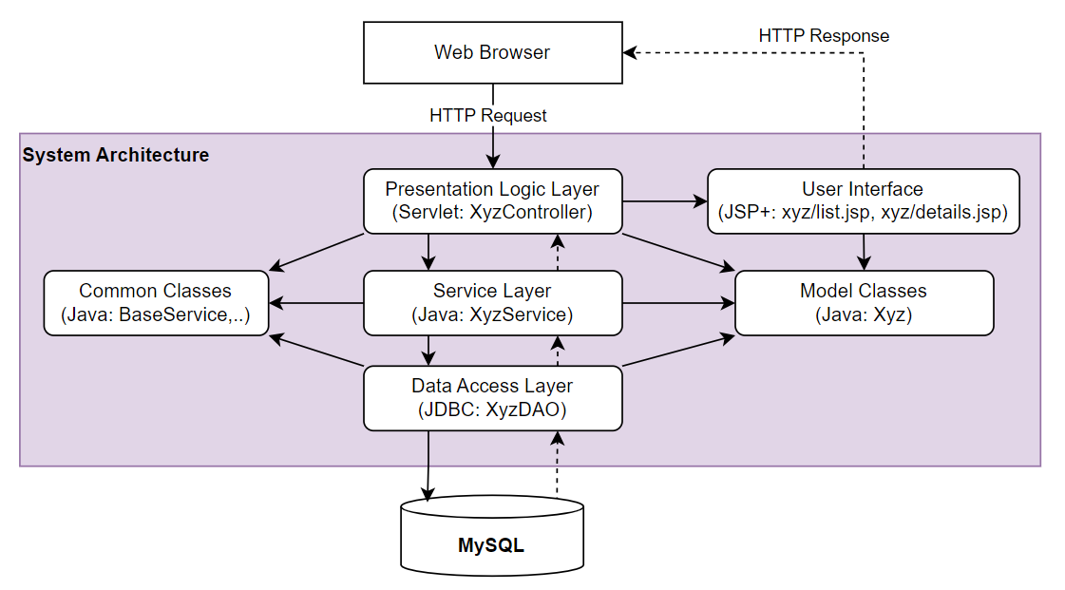-

1.2 Package Diagram
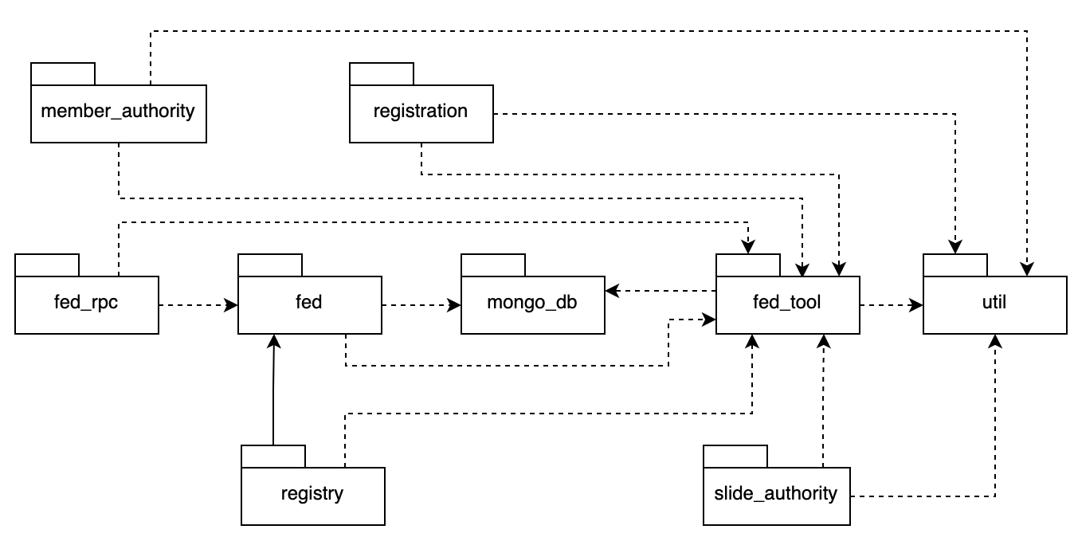
Backend Package
No | Package | Description
1 | «root» com.hcms | Bao chứa tất cả packages bên dưới
2 | config | SecurityConfig, CorsConfig, JwtConfig, SwaggerConfig, WebConfig
3 | common (Shared Kernel) | dto/, exception/, util/, constant/, base/ → ApiResponse, BaseEntity, GlobalExceptionHandler
4 | auth | controller/ → AuthController; service/ → AuthService; repository/ → UserRepository; entity/ → User, Role; dto/ → LoginReq, RegisterReq
5 | patient | controller/ → PatientController; service/ → PatientService; repository/ → PatientRepository; entity/ → Patient; dto/ → PatientReq, PatientRes
6 | appointment | controller/ → AppointmentController; service/ → AppointmentService; repository/ → AppointmentRepository; entity/ → Appointment; dto/ → BookingReq, BookingRes
7 | consultation | controller/ → ConsultationController; service/ → ConsultationService; repository/ → VisitRepository; entity/ → Visit, Prescription; dto/ → VisitReq, PrescriptionDto
8 | billing | controller/ → BillingController; service/ → BillingService; repository/ → BillingRepository; entity/ → Billing; dto/ → InvoiceRes

Frontend Package

No | Package | Description
1 | «root» frontend/src | Bao chứa tất cả packages bên dưới
2 | app/ | guards/ → PrivateRoute, RoleGuard; layouts/ → MainLayout, AuthLayout; provider/ → AuthProvider, ThemeProvider; routers/ → AppRouter.tsx; App.tsx
3 | features/ | booking/, patient/, doctor/, billing/, dashboard/, auth/ (mỗi feature: pages, components, hooks, types)
4 | shared/ | components/ → Button, Modal, Table, DataGrid; hooks/ → useAuth, useFetch, useDebounce; services/ → authService, bookingService (Axios); utils/ → formatDate, validators, constants; hoc/ → withAuth, withLoading; types/ → api.types.ts
5 | assets/ | images/, icons/, fonts/
6 | styles/ | globals.css, theme vars

1.3 Database Design
[Provide the files description, database table relationship & table descriptions like example below]

1.3.1 table_name1
[Provide brief description of the table here]
[Provide the detailed table fields description using below table format
* PK~Primary Key; FK~Foreign Key; UN~Unique; NN ~ not null
No | Field | PK | FK | UN | NN | Description
01 | <field_name1> |  |  |  |  | <Description of the field_name1>
02 | <field_name2> |  |  |  |  | …
..

1.3.2 table_name2
…

2. Detailed Design

2.1 <Feature/Function Name1>
[Provide the detailed design for the feature <Feature Name1>. It includes Class Diagram and Sequence Diagram(s); For the features/functions with the same structure of class & sequence diagrams, you need to provide the diagrams once for one feature/function and refer to those diagrams from other features/functions]

2.1.1 Class Diagram
[This part presents the class diagram for the relevant feature]
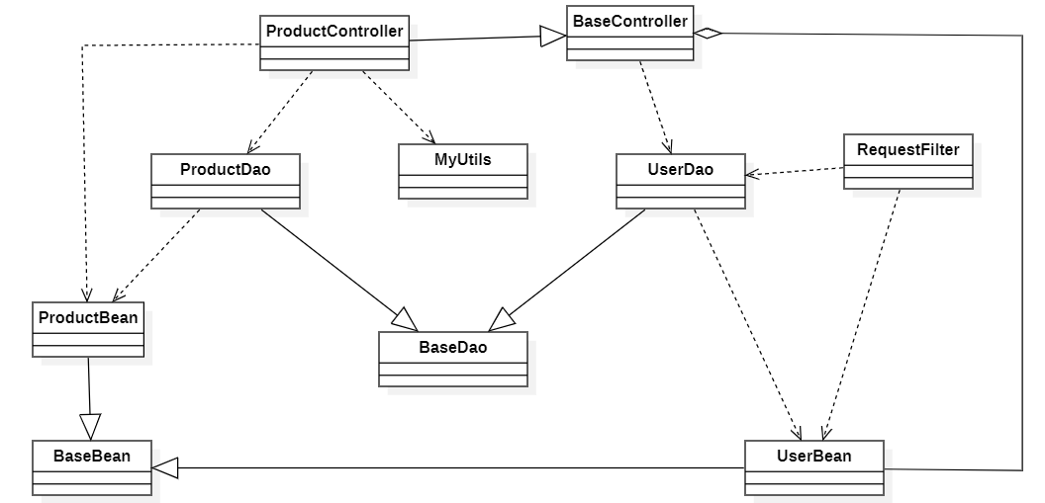

2.1.2 <Sequence Diagram Name1>
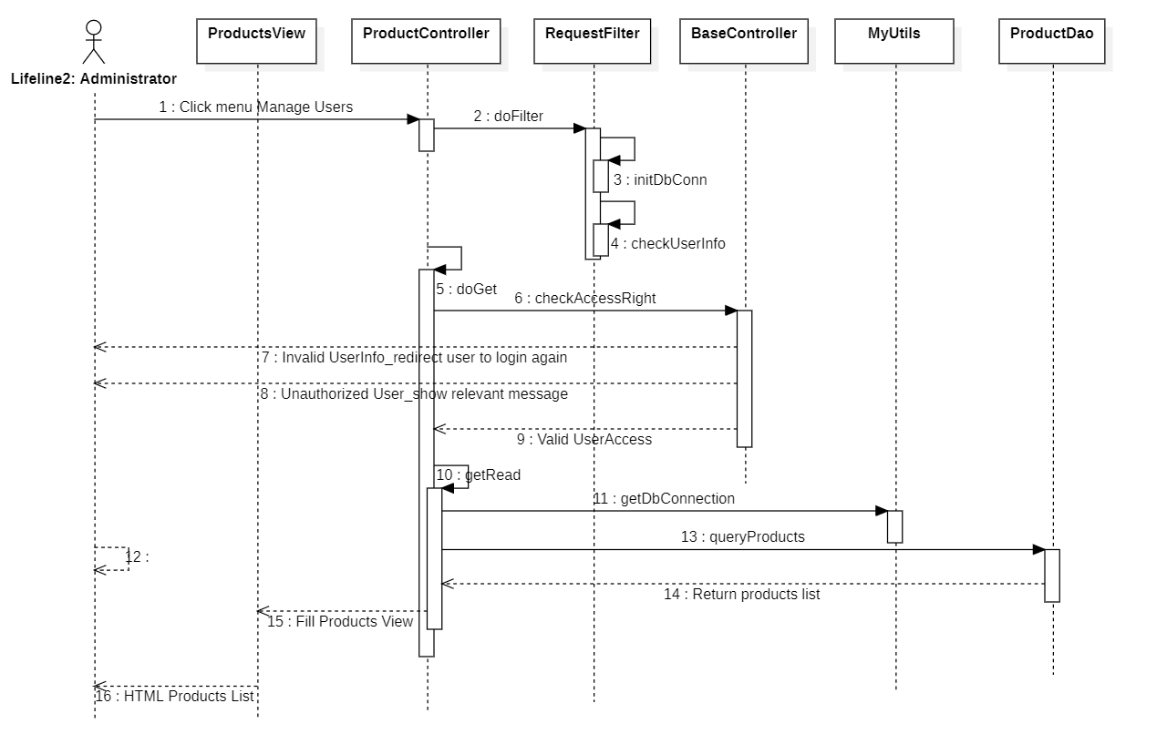

2.1.3 <Sequence Diagram Name2>

2.1.4 …

2.2 <Feature/Function Name2>
…

3. Class Specifications

3.1 package_name1
This section provides the detailed specifications for the classes in the package package_name1

3.1.1 ClassName1
[Provide brief description of the class here]
[Provide the class attributes and operations using below table format
No | Name | Description
Attributes
01 | <attributeName1> | Visibility: <attribute’s visibility: private, protected, default…>  Type: <data type of the attribute: int, String...>  Purpose: <description or purpose of the attribute>
02 | <attributeName2> | …
..
Methods/Operations
01 | <methodName1> | Visibility: <operation’s visibility: private, protected, default…>  Return: <void or return type of the operation: int, String,..>  Purpose: <description or purpose of the method>  Parameters: <<list out all the method parameters and provide details (name, data type, purpose/description) of each method parameter here  - paramName1:type1, purpose/description1  - paramName2:type2, purpose/description1  >>
02 | <methodName2> | …
..
]

3.1.1 ClassName2
…

4. Other Design Specifications
[Provide any other design specifications here: data design, system integrations, algorithms, etc.]

…

